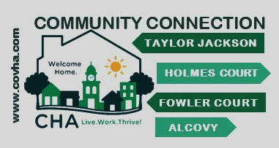
H
Unit No ……
The Feb-March Code Word is
……………………
……………………
It $ to Read
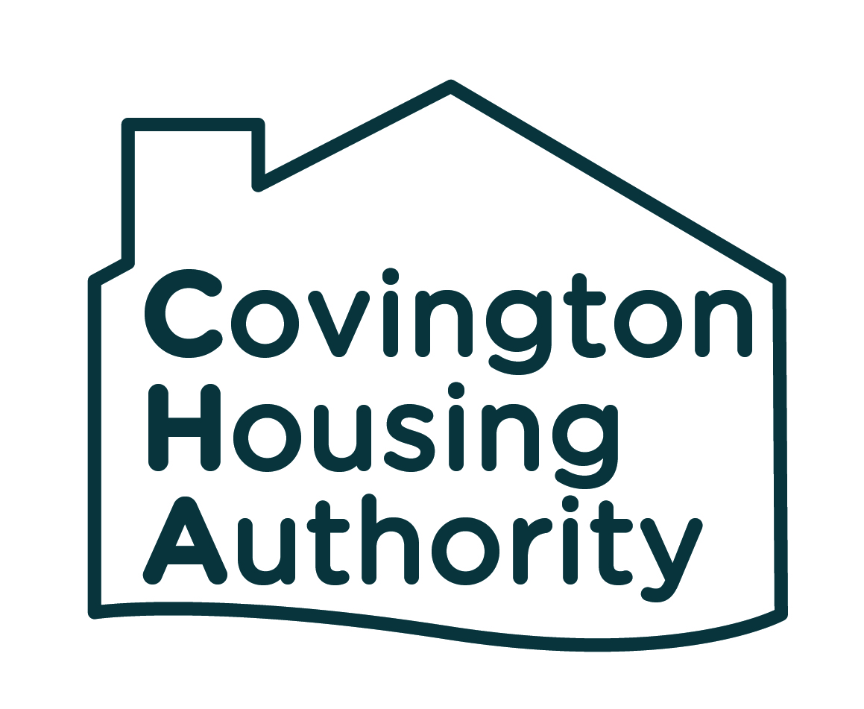

February – March, 2022
be in a drawing for a special prize

It Pays to Read
Read your newsletter & know what is going on in your community.
Every month find the special code words in the resident newsletter.
Write the code words on the Pays to Read ticket.
Clip it out & return to the office with your rent payment.
You will be entered in the drawing for February – March Prize

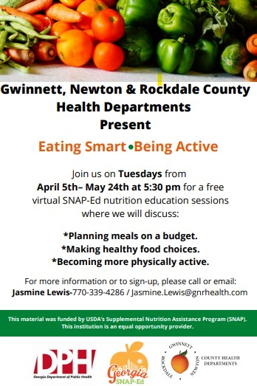
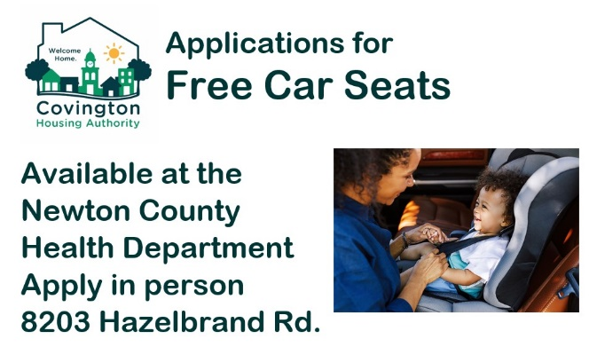
RESIDENT HEALTH & WELLNESS

Are you interested in owning your own home?
Invest in yourself and take these classes.
More information is available on the website
www.covha.com/applyforhousing
Or call Josephine Kelly
770-786-7739

RESIDENT REMINDERS
Lease Compliancy
- Residents must report changes in the household to CHA Housing Staff immediately. These changes include
a. A household member moves out of the unit
b. The household income increases by $200 a month
Housing staff are available during office hours to discuss change notifications.
Residents can also send questions to housing@covha.com
The Household Change Notification Form is always available at the Front Door of the CHA office. Code Word Porch Furniture
- Guests/Unauthorized residents
a. House Rules – No guest will be permitted to visit overnight for no more than fourteen nights within a 12-month period
b. Adding a resident to your lease requires an application to be submitted. The applicant cannot move in before the application is submitted and processed by CHA Housing Staff.
c. Having unauthorized residents living in your unit is considered a violation of your lease (material non-compliance)
Litter
- In your lease residents agreed to not litter grounds or common areas. Those residents who are throwing trash out on the right-of-way on Turner St. are asked to stop this immediately.
Facilities Maintenance
- Residents will receive service charges
1. For all repairs for damages caused by a residents or resident’s guests
2. For not reporting a maintenance issue which creates further damage to the unit.
- Residents who are found not following the parking policy, by parking on the grass, will receive a $80.00 fine.

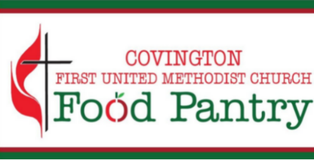
The Food Pantry Ministry assists those in need with food every month.
Hours: Monday/Wednesday/Friday afternoons 2-4pm, households may come once per month
Location: 2160 Church St, Covington 30014 (from the Church St/Conyers St intersection, pass the main church, pass the youth house,
the food pantry will be on your right)
Line up in your vehicle on Church Street; volunteers will register you from your car and bring food to your car
Please bring your photo ID and have a list of names and birth date of your household members.
Senior Deliveries: This ministry delivers food boxes once a month to home bound seniors who are unable to come to the food pantry.
They currently have a waiting list for senior deliveries. To be added to the waiting list, please either email foodpantry@covingtonfirst.org
or call (770)786-7305. Leave your name, birth date, and address.
Covington Food Pantry Ministry will contact you when they are able to add you to their delivery list.
Let’s stay in contact & be connected.
CHA is on
https://www.facebook.com/covingtonhousingauthority FACEBOOK
https://www.instagram.com/covingtonhousingauthority/ INSTAGRAM

