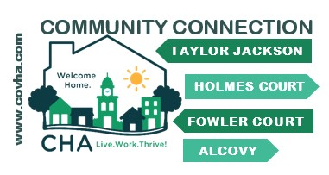

January – February  
**Let’s stay in contact   
and be connected**.   
The Covington Housing Authority is on FACEBOOK and INSTAGRAM There are regular posts with information for CHA residents.

HEALTH & WELLNESS

Gwinnett, Newton, Rockdale Health Department   
YOUR Health & Wellness PARTNER

#### GNR is an affordable and convenient alternative to meet your family’s healthcare needs GNR provides the following services

* Immunization Clinics,
* Women’s Health, Family Planning and Child Health Clinics
* DNA testing,
* Drug testing, and lab testing.
* Women Infant and Children Food Program
* Children’s Dental Clinics

Infectious disease and testing such as Covid -19, TB and Sexually Transmitted Infections

Carolyn Callaway is the GNR Client Navigator for the BCCP/Breast and Cervical Cancer Program  
Carolyn is at the District Office2570 Riverside Parkway, Lawrenceville, GA. 30046 PH (678) 231-9163. She is an excellent resource and is ready to assist anyone who is undergoing treatment for these health issues.  
Sign up now for the next session of Eating Smart & Being Active with Jasmine Lewis  
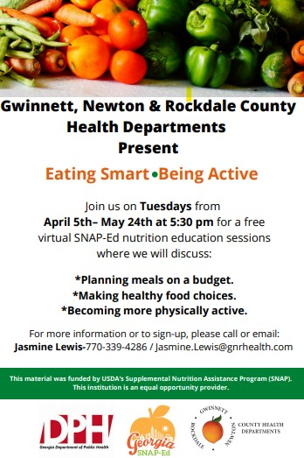

**NEW INFORMATION FROM THE CDC**  
**Vaccines** Research has shown that receiving 2 Covid-19 vaccines, plus a booster shot can prevent you getting Covid-19 or lessen its symptoms  
**Don’t Stop Masking**   
Wear masks with- A proper fit over your nose and mouth to prevent leaks  
- Multiple layers of non-woven material  
- A nose wire  
**Quarantining**  
**People with COVID-19** should isolate for 5 days and if they are asymptomatic or no longer have symptoms (without fever for 24 hours), follow that by 5 days of wearing a mask when around others to minimize the risk of infecting people they encounter. The majority of SARS-CoV-2 transmission occurs early in the course of illness, generally in the 1-2 days prior to onset of symptoms and the 2-3 days after.  
**People exposed to COVID-19.** For people who are unvaccinated or are more than six months out from their second mRNA dose (or more than 2 months after the J&J vaccine) and not yet boosted, CDC now recommends quarantine for 5 days followed by strict mask use for an additional 5 days. If a 5-day quarantine is not feasible, an exposed person should  [wear a well-fitting mask](https://www.cdc.gov/coronavirus/2019-ncov/your-health/effective-masks.html) at all times when around others for 10 days after exposure. Individuals who have received their booster shot do not need to quarantine following an exposure, but should wear a mask for 10 days after the exposure.  For all those exposed, best practice would also include a test for SARS-CoV-2 at day 5 after exposure. If symptoms occur, individuals should immediately quarantine until a negative test confirms symptoms are not attributable to COVID-19.  
**Testing**Every home in the U.S. is eligible to order 4 free at-home COVID-19 test kits. Orders are expected to ship in 7-12 days.  
Visit https://www.covidtests.gov/ to place your order.For assistance scheduling a vaccine appointment, please visit   
gta-vras.powerappsportals.us/en-US/ or call the Georgia Department of Public Health Resource Line 888-457-0186

RESOURCES  
FOR RESIDENTS

EDUCATION

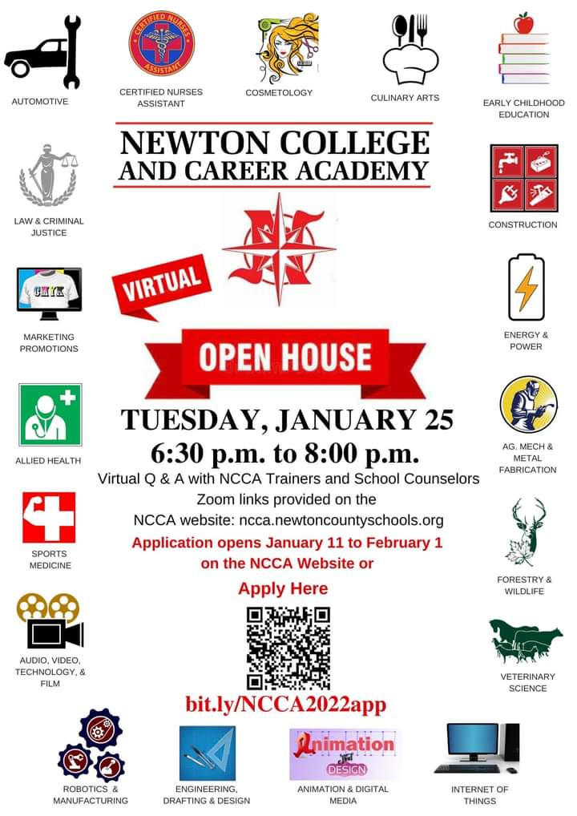

Parents and students, applications for the Newton College and Career Academy are open. The Academy allows students to move directly to their career paths, earn industry credentials and their high school diploma, a virtual Open House is scheduled from 6:30 - 8:00 PM on January 25, 2022.

<https://ncca.newtoncountyschools.org/home>  
Parents, another opportunity to support your student as they make important choices about their future career  
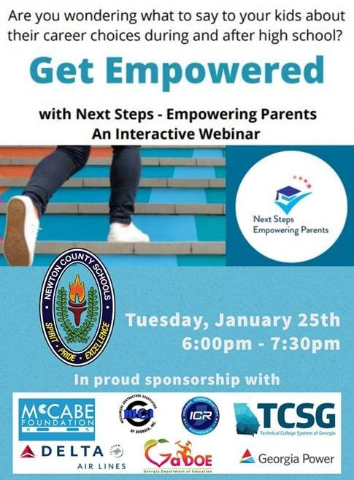

Job Openings   
Residents if you would like to update your resumes or do some preparation before applying for a job, call Josephine Kelly – Community Relations Ph. 770-786-7739 and set up an appointment. It can be in-person or on Zoom. Appointments can made, based on the resident’s schedule.



Employment openings Newton County Schools  
newtoncountyschools.tedk12.com/hire/index.aspx

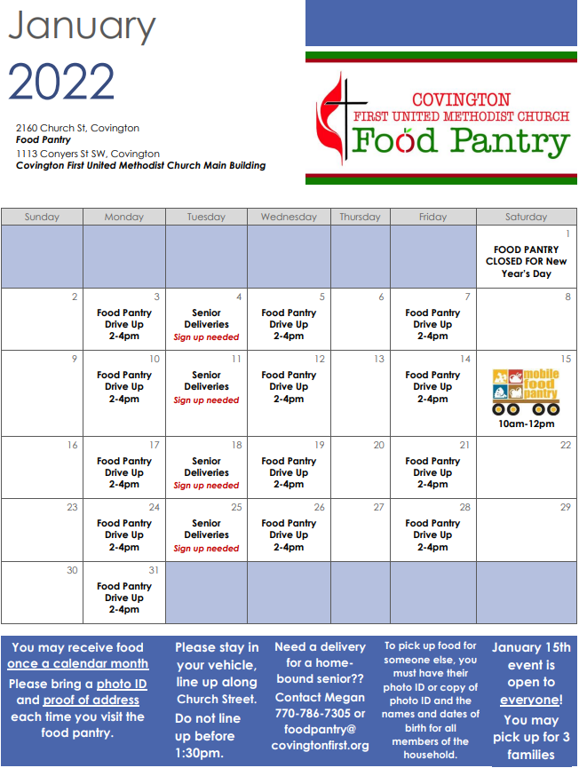

To make an application for rent assistance  
https://georgiarentalassistance.ga.gov/

https://newtoncountyschools.tedk12.com/hire/index.aspx